

**Team**

**BVRIT HYDERABAD**

**College of Engineering for Women**

**Department of Information Technology**

**Major Project - Academic Year 2019-20**

**TEAM**

**4**

**Tools and Technologies**

* **Android Studio**

**Conclusion and Future Scope**

Text to speech and speech to text synthesis is a rapidly growing aspect of computer technology and is increasingly playing a more important role in the way we interact with the system and interfaces across a variety of platforms. We have  developed a very simple and attractive graphical user interface which allows the user to type in his/her text provided in the text field in the application, converts the speech to text, allows the user to upload text files and the android read out the text messages the user receives. In future, we plan to work on  the implementation of a text to speech system on other platforms, such as telephony systems, ATM machines, video games and any other platforms where text to speech technology would be an added advantage and increase functionality.

**Guide**

**Ms. S. Rama Devi**

**Associate Professor, IT**

**ramadevi.s@bvrithyderabad.edu.in**

**Architecture**

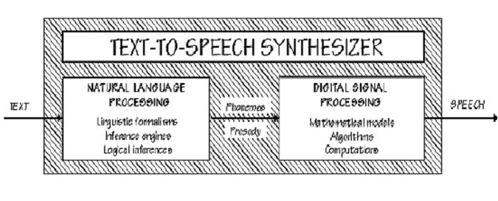

**Modules**

Text to Speech: It converts from Text to Speech

Speech to Text: It converts from Speech to Text

Image Processing: It recognizes the image and reads the text on the image

File Uploader: We can upload the files which are converted to Speech

Notification Reader: It reads all the notifications

**Abstract**

A Tap Tap Search is an Android Application. The main idea of this project is to recognize the text character and convert it into a speech signal. Here, we developed a useful text-to-speech synthesizer in the form of a simple application that converts inputted text into synthesized speech and reads out to the user. We also implemented Speech to Text where it takes the speech from the user and it converts into text and also implemented notification reader where if the user receives any text message from any one then it will tell what is the message received and the sender’s number. In this application we implemented a feature of uploading text files  and the android takes the text and that will be converted into speech.

**Web 2.0 technologies made users to spend more time on the Internet to search for answers about various questions.**

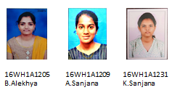

**TAP TAP SEARCH**